**POLITECNICO DI TORINO, SOFTENG GROUP**

**INFORMATION SYSTEMS**

**DIGITAL METRO TICKET PROJECT IN THE TASHKENT UNDERGROUND**

Students: Abdunabiev Shahbozbek Professor: Maurizio Morisio  
 Faiziev Bobur

**ABSTRACT**

This project assignment is about metro ticketing system of Tashkent underground. It consists from two parts: AS IS and TO BE. The AS IS part describes the current situation of the organization. Moreover, the TO BE part should propose changes in order to optimize some processes in the organization.

**0. TABLE OF CONTENTS**

ABSTRACT

1. TABLE OF CONTENTS
2. INTRODUCTION
3. AS IS  
   2.1 VARIABLES  
   2.2 VIEWS  
    2.2.1 IT VIEW  
    2.2.2 FUNCTIONAL VIEW  
    2.2.2.1 CLASS DIAGRAM  
    2.2.2.2 BPMN ACTIVITY DIAGRAM  
   2.3 KPI EVALUATION
4. TO BE  
   3.1 VIEWS  
    3.1.1 IT VIEW  
    3.1.2 FUNCTIONAL VIEW  
    3.1.2.1 CLASS DIAGRAM  
    3.1.2.2 BPMN DIAGRAM  
   3.2 KPI EVALUATION
5. CONCLUSION

**1. INTRODUCTION**

There is list of tasks for completing the project and they are as following: analyze organization, legal issues; list processes; select process (model process); propose improvement (new process, new technology, what IS, what tools, cost, returns).

**2. AS IS  
 2.1 VARIABLES**

**A. Size**The number of employees is 3047 (three thousand and forty-seven). “Tashkent Metropoliteni” serves 54 000 000 (fifty-four million) passengers per year / 150 000 (one hundred and fifty thousand) passengers per day. This information is related to 2014 year’s statistics.   
**B. Goal**Provide good, reliable and well-organized public transportation service for people.  
**C. Profit**   
The organization is public and non-profitable. In 2014 revenue of the organization was 23 450 000 $ (twenty-three million four hundred and fifty thousand US dollar).   
**D. Culture and Politics**   
Rigid culture, dress code, stable environment, security, routine tasks.  
**E. Organizational Structure**   
“Toshkent Metropoliteni” State Unitary Enterprise (SUE) is the official name of the organization. The brief description of the SUE is the following: “A unitary enterprise is a government-owned corporation. Unitary enterprises are business entities that have no ownership rights to the assets that they use in their operations. This form is possible only for state and municipal enterprises, which respectively operate state or municipal property.” The organization is the part of “Toshshahartransxizmat” Joint Stock Company (JSC). The following chart represents organizational structure of the parent company:   
  
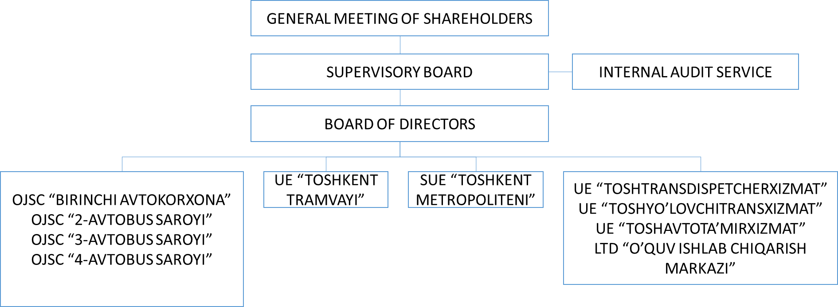

*Picture 2.1*

The board of directors is shown in below:   
  
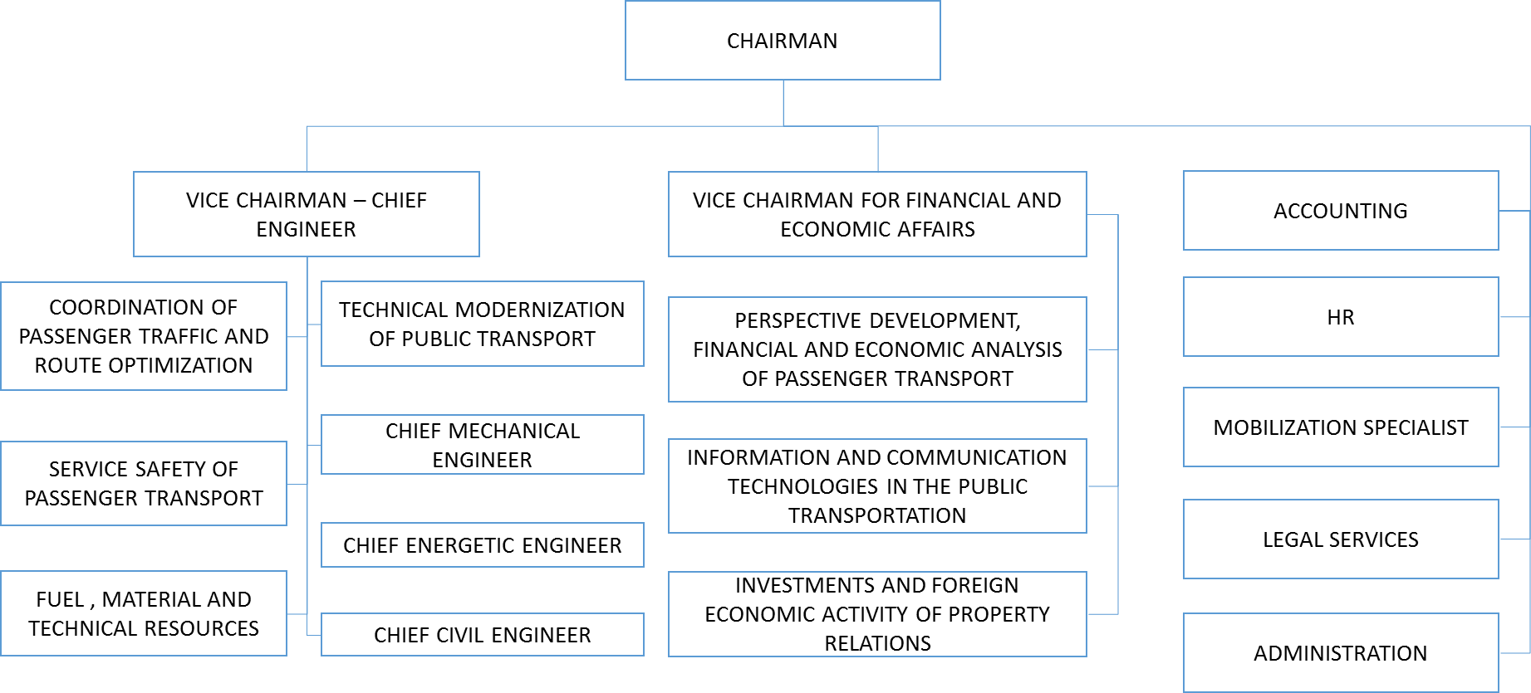

*Picture 2.2*

The following is the structure of the organization:  
  
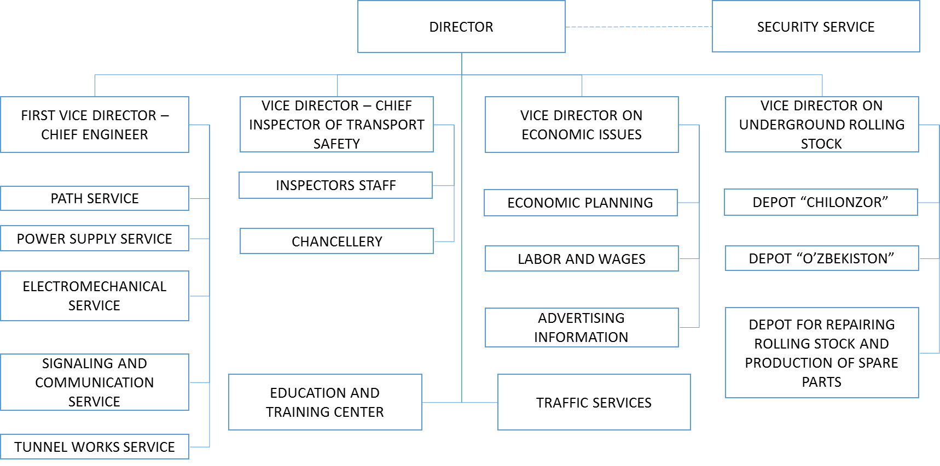

*Picture 2.3*

Like mechanical system:  
- Vertical structure  
- Formal systems  
- Efficient performance  
- Security

**2.2 VIEWS  
2.2.1 IT VIEW**

Each station of the organization includes:  
- Ticket selling points (paper based, human resources)  
- Advertisement displays  
- Surveillance cameras  
- Room for surveillance with displays and pc  
- Communication devices, signalization devices  
- PC in order to track everything in the station

Central administration:  
- LAN  
- Database (for accounting, for materials)  
- Accounting applications  
- Not well centralized in terms of IS  
- Well centralized in terms of security system

Signaling and communication:  
- Signalization  
- Communication

**2.2.2 FUNCTIONAL VIEW**

|  |  |
| --- | --- |
| Functional area | Business Process |
| Traffic Services | ***Ticket Distribution Ticket Selling  Ticket Gathering***  Station Cleaning |
| Depots | Check trains for safety  Clean trains  Prepare trains for the next usage |
| Finance and Accounting | Calculating salaries  Buying material |
| Depot for repairing rolling stock and producing spare parts | Producing spare part  Designing spare part  Ordering raw material |

**2.2.2.1 CLASS DIAGRAM**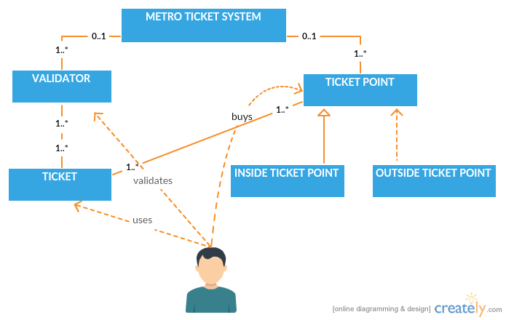

*Picture 2.4*

**2.2.2.2 BPMN ACTIVITY DIAGRAM**

**A. Ticket Buying  
  
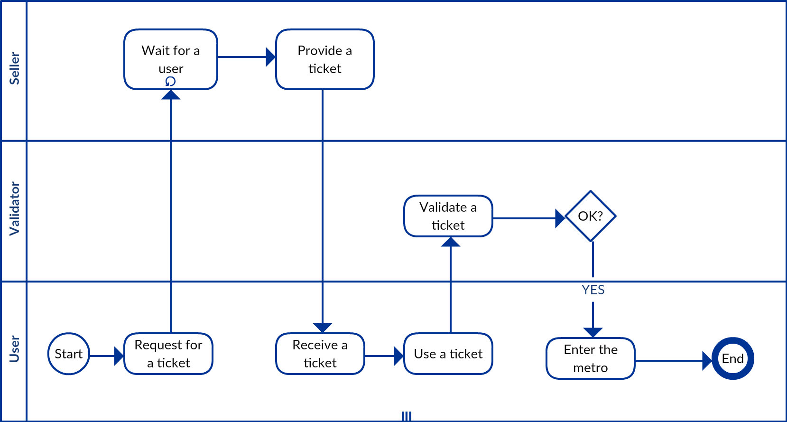**

*Picture 2.5*

**B. Ticket Gathering  
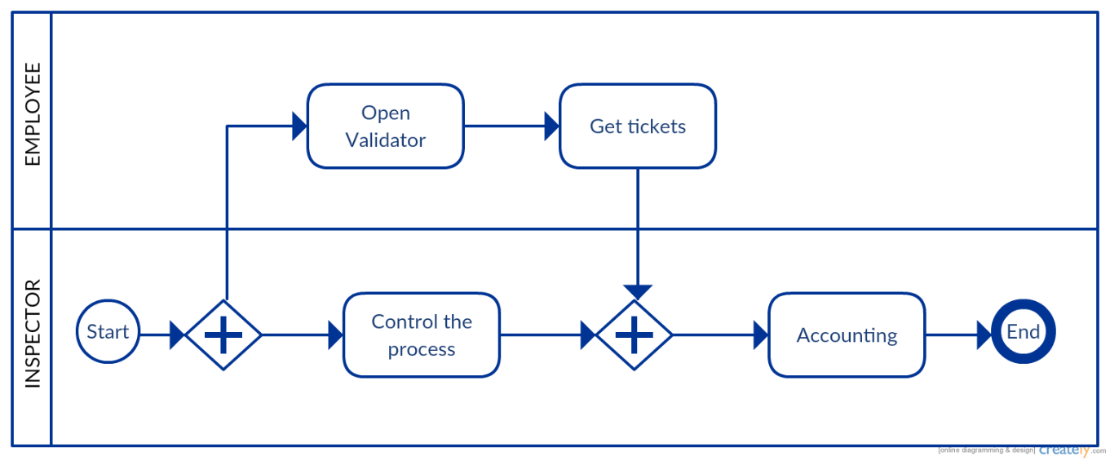**

*Picture 2.6*

**2.3 KPI EVALUATION**

Before starting, there are some numbers (officially published in 2014, below the link of the source: *http://eng.asmetro.ru/upload/docs/2014.pdf*):  
- Number of employees: 3047 (three thousand and forty-seven)  
- Ridership per year: ≈ 54 000 000 (fifty-four million)  
- Ridership per day: ≈ 150 000 (one hundred and fifty thousand)  
***- Expense per passenger: ≈ 1530 UZS (one thousand and thirty Uzbekistan sum) (66 ¢ (sixty six US cents))***  
- Ticket cost: 1000 UZS (one thousand Uzbekistan sum) (43 ¢ (forty three US cents))  
- Revenue: 23 450 000 $ (twenty-three million four hundred and fifty thousand US dollar) per year  
- Expenses: ≈ 36 000 000 $ (thirty six million US dollar)

|  |  |
| --- | --- |
| GENERAL | * Input volume (# of tickets): ≈ 148 000 (estimated) per day * Output volume (# of passengers): ≈ 150 000 (there are passengers with discount) per day * Human resources (# of personnel for ticket system): ≈ 52 entrances (2*2+2) personnel ≈ 300 personnel (estimated) * Non-human resources (# of ticket offices, #of validators): 52 ticket offices, ≈ 52 entrances*6 validators ≈ 300 |
| EFFICIENCY | * Cost per unit (total cost/# of passengers): 0.66 (USD) * Productivity of resources: 148 000 tickets/300 personnel ≈ 495, 148 000 tickets/(300*9 person hours) = 54 tickets per person hour * Utilization of resources: # of used person hours/# of available person hours |
| QUALITY | * Customer satisfaction: social network analysis, interviews |
| SERVICE | * Response/Lead time (waiting time in queue+service time for buying ticket) – max: 5 minutes, min: 30 seconds–1 minute (estimated) |

**3. TO BE**

We are going to use contactless smart card and paper based tickets at the second part of our project. Contactless smart cards must only be in near proximity to the reader (generally within 10 centimeters) for data exchange to take place. The contactless data exchange takes place over radio frequency (RF) waves. The device that facilitates communication between the card and the reader are RF antennae internal to both the card and the reader. Long-time-usable RFID cards can be a suitable example for such contactless smart cards. The TO BE part of the project uses long-time-usable RFID card and paper based ticket instead of one-ride token. Characterization of such tickets and RFID cards is one or more ride by metro. RFID card contains the type of a card and stores the time it is used and possibly other needed information. RFID cards and paper based tickets can be obtained at outside ticket offices and in addition paper based tickets are sold in vending machines (installed in the entrance of the stations). Paper based tickets can be thrown away, when it has been used. Long-time-usable RFID cards are usually (re)chargeable and can be loaded through the recharge machines. This RFID card is meant to be used for a long time. Users can also use their NFC-enabled mobile device as a ticket and grant access to the metro by using special mobile application. In the future this ticketing system can be also implemented for surface (bus, trolleybus, tram) and any means of transportation with unlimited number of transfers and time limitation.

Following issues are important in TO BE part of the ticketing system project:  
- Ease-of-use for passengers  
- Equity (types of users, types of trips)  
- Simplicity of revenue collection  
- Ease-of-control for operators  
- Attractiveness to passengers  
- Intermodality (transfer tickets)  
- Simplicity of clearing and sharing revenues between operators  
- Maximizing fare box revenues  
- Reducing fraud

Ticket Types:  
- Single ticket: one journey (no time limit)  
- Multi-journey ticket (5, 10, 20)  
- Season ticket (day, week, month, year)

Ticket Media Types:  
- Contactless smart card (RFID card)  
- Paper based ticket (for one-time usage)

- Mobile ticketing

User classes:

-Pupil and student

-Elderly people and pensioners

-Disabled people

-Police and army

**3.1 VIEWS**

**3.1.1 IT VIEW**

Three tiers (data server, application server, presentation server) of client / server architecture model is used in TO BE part of the project. Vending, recharge machines and validators play client role. Because of urban area range there is used MAN (Metropolitan Area Network) network extension with bandwidth 100M-1Gbps. The networking mode is intranet.   
Client:   
- Vending/recharge machines  
- Validators (featured with RFID reader and paper based ticket reader)  
Server:   
- MAN  
- Database

**3.1.2 FUNCTIONAL VIEW  
3.1.2.1 CLASS DIAGRAM**

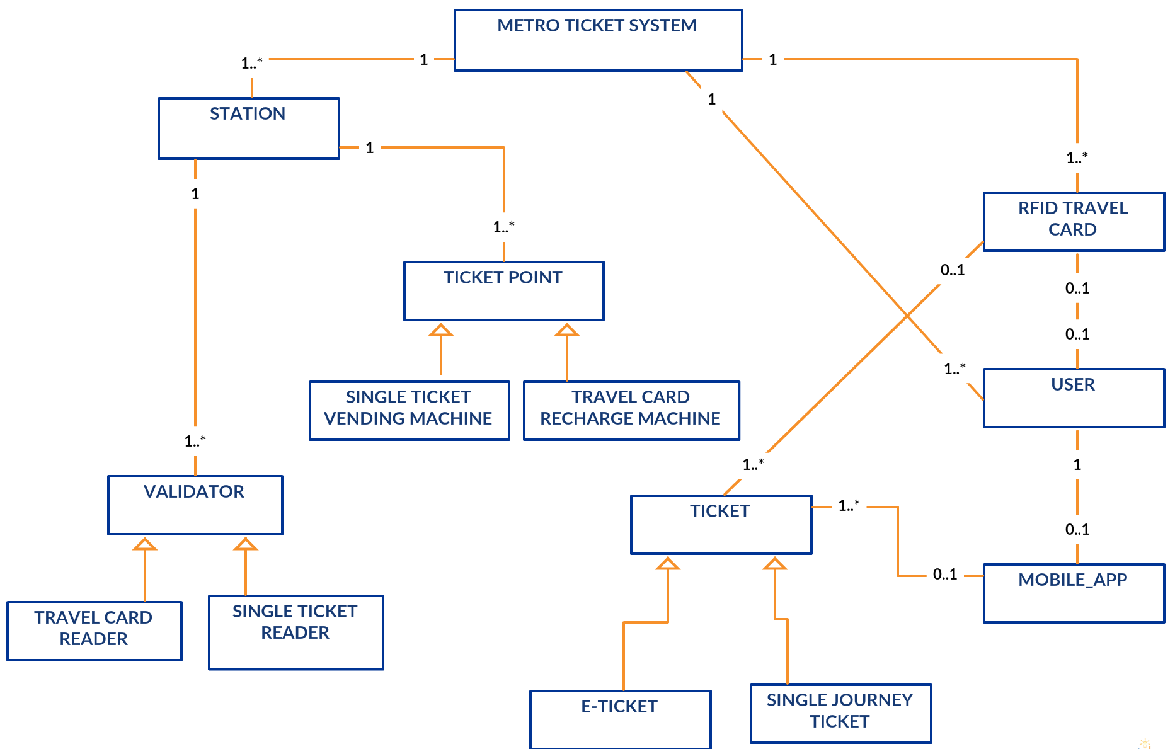

*Picture 3.1*

Above we can see the class diagram for the new system. There are some comments on it:

* Not all users have RFID travel card
* Not all RFID travel cards are tight to users
* User identification is necessary only for season tickets (month, year) and discount for different user classes (student, pensioner, …)
* User can use mobile app for buying tickets and storing them. Reader using phones NFC card can validate ticket. User holds account for using mobile app.

**3.1.2.2 BPMN ACTIVITY DIAGRAM**

We have rather complex activity diagrams comparing to, AS IS situation. But we get rid of a ticket gathering activity. In the following pictures you can see ticket buying with travel card and phone, ticket validation.

In the first picture, the payment can be done by means of cash or bank card. If it is done by bank card, we have external entity involved in our activity. In the second one, we can not use of cash. Therefore, we can use only mobile or internet banking to authorize the payment.

**A. Ticket Buying with RFID Card  
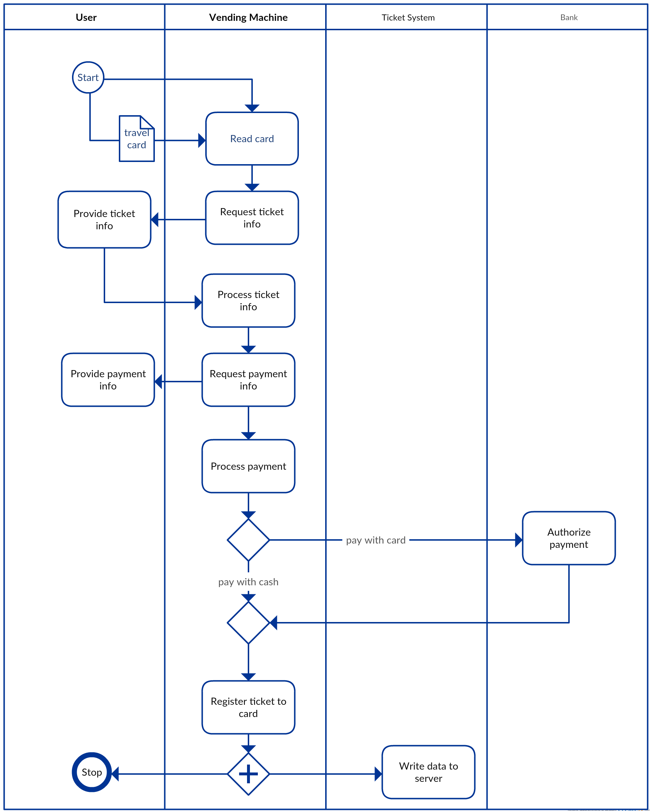**

*Picture 3.2*

**B. Ticket Buying with NFC-enabled Mobile Device  
  
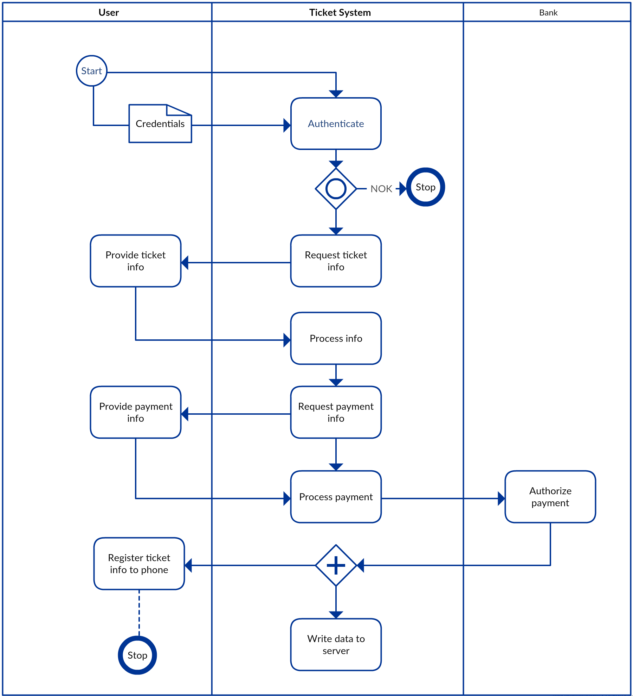**

*Picture 3.3*

**C. Ticket Validation  
  
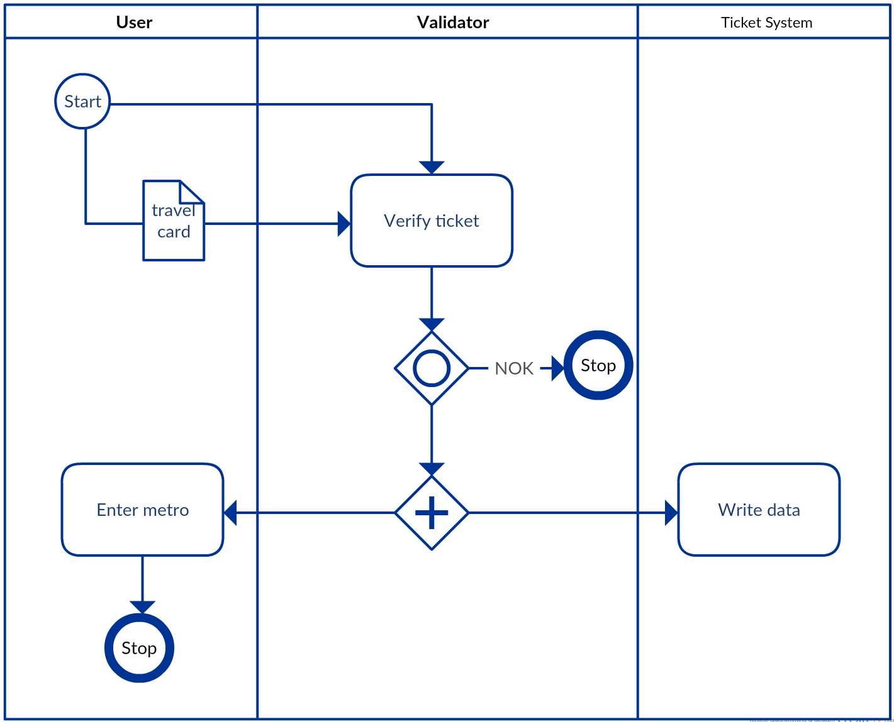**

*Picture 3.4*

**3.2 KPI EVALUATION**

|  |  |  |  |
| --- | --- | --- | --- |
| **Category** | Name | Description | Unit |
| **GENERAL** | N_T | Number of tickets sold per year |  |
| N_C | Number of travel cards issued per year |  |
| N_CT | Number of travel card tickets sold per year |  |
| N_PT | Number of mobile phone tickets sold per year |  |
| N_TR | Estimate ridership per ticket type and route |  |
| AN | Analyze travel patterns |  |
| **EFFICIENCY** | C_T | Cost per unit | USD |
| C_CONT | Cost for controlling and validation | USD |
| **QUALITY** | N_LFT | Number of lost, fake and defective tickets |  |
| CUS_SAT | Customer satisfaction |  |
| MAN | Improved crowd management |  |
| **SERVICE** | L_T | Lead/Response time to buy a ticket | Sec/min |
| L_TV | Lead/Response time to validate a ticket | Sec |

**4. CONCLUSION**

**4.1 Comparision KPI**

|  |  |  |
| --- | --- | --- |
| **Name** | **AS IS** | **TO BE** |
| **N_T** | = | = |
| **N_CT, N_PT** | - | New kind of tickets with different types |
| **N_TR** | - | Helps to analysis and management |
| **AN** | - | Helps to analysis and management |
| **C_T** | - | If we take a single ticket cost without considering cost of the new system, it decreases. Because we can use the card many times. But, if we consider all costs, it may decrease after several years |
| **C_CONT** | Ticket gathering, accounting and distribution | It decreases, because it is not necessary to gather tickets and do accounting |
| **N_LFT** | There are lost, broken and fake tokens in the time of gathering, accounting and distributing. | It decreases, because ticketing system is automated. Moreover, there are electronic tickets. |
| **L_T** | Because of queues, a user can wait up to 5 minutes | It may decrease by means of electronic ticketing |
| **L_TV** | Several seconds | May decrease, because cards are contactless |
| **CUS_SAT** | Ticket system is not flexible. There are no ticket types for different classes of users. There is no discount for buying several tickets. | It is possible to increase customer satisfaction by introducing new ticket types. |
| **MAN** | No such possibility, because no tracking info | Possible by tracking users and analyzing gathered information by validators and vending/recharging machines |

**4.2 SHIFTING TO THE NEW SYSTEM**

In order to move to the new system we need to install all components as described in it view. Therefore, it is necessary to consider following costs:

* **Construction cost (C_C)**. It is the cost for upgrading existing components (e.g. validators), buying new components (server, validators, vending machines, recharge machines) and software development.
* **Deployment cost (C_D)**. It is cost for installing new hardware and software components and training personnel.
* **Operation and maintenance (C_OM).** It is necessary to control system and assure that is working properly. Therefore, we need to consider cost for controlling hardware and software components of the system.
* **Dismissal cost (C_DIS)**

At the end overall cost as following,

**COST_TO_BE = C_C + C_D + C_OM + C_DIS.**

**4. 3 SAVINGS**

We need to identify where savings can come from. Therefore, we introduce following costs:

* **Cost for personnel.** It is cost for personnel worked in AS IS ticketing system.

**C_P = 300 personnel* 350 (USD/month per personnel) * 12 (month) ≈ 1.**3 mln USD

* **Cost of AS IS ticket.** It is cost for AS IS situation tickets.

**C_T_AS_IS = #of_new_tickets_per_year * cost_per_ticket**

* **Cost for TO BE tickets.** This cost is mainly for one time paper based tickets.

**C_T_TO_BE = #of_single_ticket * cost_per_ticket**

* **Cost of control (C_CONT).**
* **Cost for maintenance of inside ticket offices (C_M).**
* **Cost for maintenance ticket validators (C_MV).** The current validators are too old and consist of mechanical parts. Therefore it requires more effort and time for maintenance.

At the end of our cost analysis we can derive formula for savings,

**S = (C_P + C_T_AS_IS + C_CONT + C_M + C_MV – C_T_TO_BE)*years – COST_TO_BE**

**4.4 Conclusion**

As a conclusion, we can say **S** may be positive after several years by decreasing cost for **C_P, C_T_AS_IS, C_CONT, C_M**. Moreover, the new system can attract more passengers and metro system can increase its revenue. As we mentioned in comparison of KPIs, the new system improves management and increases customer satisfaction. New ticket types increase flexibility of the system towards users. In addition, lead/response time for buying ticket may decrease because of mobile phones and automatic ticket recharge machines. It simplifies validation of the ticket. The new system can be enhanced by introducing new web services for online ticket buying. And it can be applied to other modes of public transportation (bus, tram). In any case, the old system is obsolete and we have to upgrade it. Therefore, RFID cards and NFC-enabled phones based solution is a good candidate for the new system.